Computer Programming  
Lab Tasks



Department of Computer Science - BUIC

Name: Saad Ahmad

Enrollment Number: 01-134222-130

**Exercises/Lab Journal 12**

**Task 1:**

Write a program that reads the characters from a text file. It counts total number of character and total number of vowels in the file.

Code:

#include <iostream>

#include <fstream>

#include <string>

using namespace std;

int main() {

string check;

//To write to a file

/*ofstream out;

out.open("hello.txt");

out << "The quick brown fox jumps over the lazy dog";

out.close();*/

ifstream in;

in.open("hello.txt");

getline(in, check);

int counter = 0;

int i = 0;

int vowel = 0;

while (check[i] != '\0') {

counter++;

if (check[i] == 'a' || check[i] == 'e' || check[i] == 'i' || check[i] == 'o' || check[i] == 'u'

|| check[i] == 'A' || check[i] == 'E' || check[i] == 'I' || check[i] == 'O' || check[i] == 'U') {

vowel++;

}

i++;

}

cout << "There are " << vowel << " vowels and " << counter << " characters in this file";

return 0;

}

Output:

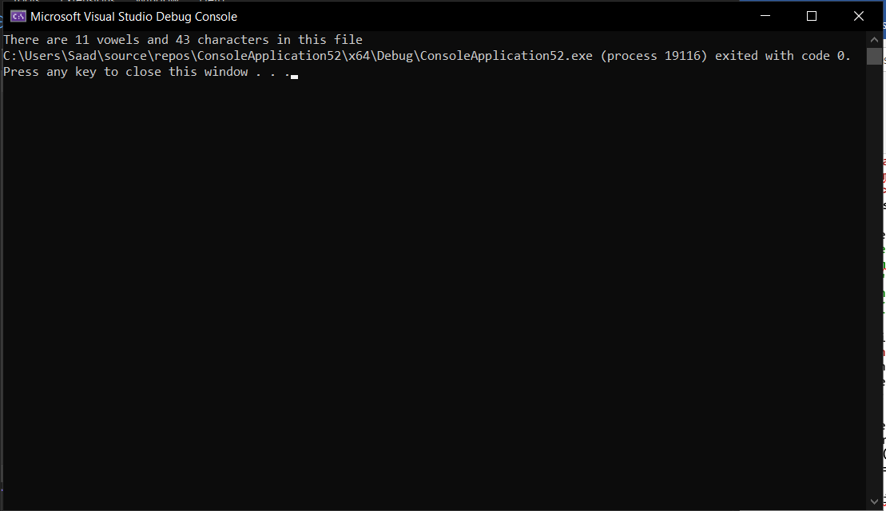

**Task 2:**

Write a program that reads a text file which has a poem written in it. (Write down the poem yourself in a text file manually). Your program should display that poem and count total number of lines in the file.

**Code:**

#include <iostream>

#include <fstream>

#include <string>

using namespace std;

int main() {

string line;

int counter = 0;

ifstream in;

in.open("hello.txt");

while (!in.eof()) {

getline(in, line);

cout << line << endl;

counter++;

}

cout << endl;

cout << "There are " << counter << " lines in this poem" << endl;

return 0;

}

**Output:**

